**Lab no 8**

**Objective: To learn XML schema and parsing an XML document.**

1. Create an XML document structuring information for a store. (shopping store of your choice)

<?xml version="1.0"?>

<store xmlns="http://www.w3schools.com"

xmlns:xsi="http://www.w3.org/2001/XMLSchema-instance"

xsi:schemaLocation="http://www.w3schools.com store.xsd">

<product> Bike</product>

<model>24-inch Boys Mountain Bike</model>

<price>$200.00</price>

<color>Black</color>

<product> Bike</product>

<model>24-inch Boys Cruiser Bike</model>

<price>$150.00</price>

<color>Blue</color>

<product>skateboards</product>

<model>Acme Sportsmen Skateboard</model>

<price>$75.00</price>

<color>Black</color>

<product> skateboards</product>

<model>Deluxe Boys Skateboard</model>

<price>$35.00</price>

<color>Blue</color>

</store>

1. Create DTD for store XML Document. And validate on <http://www.w3schools.com/xml/xml_validator.asp>

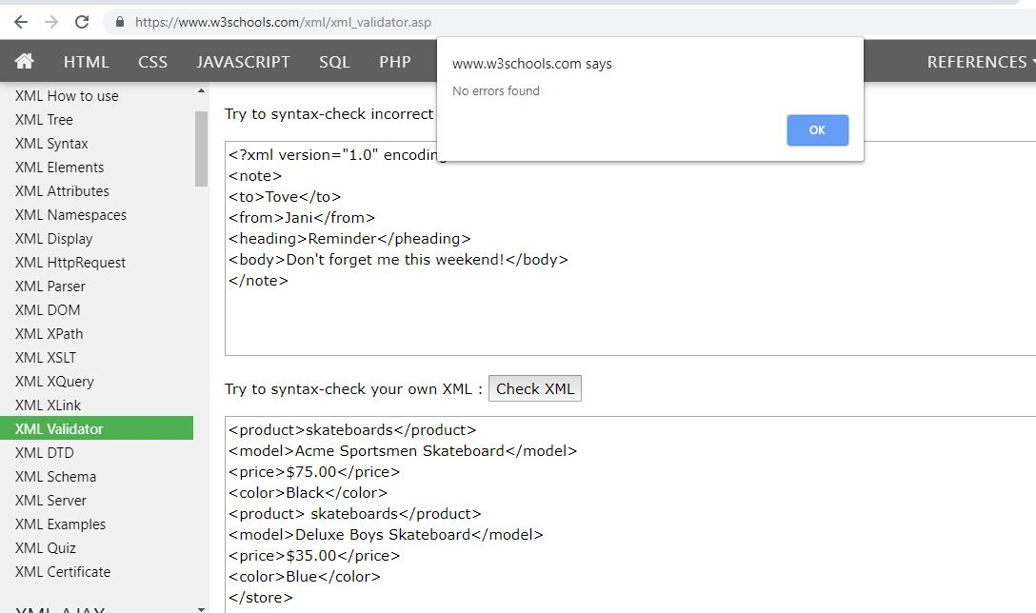

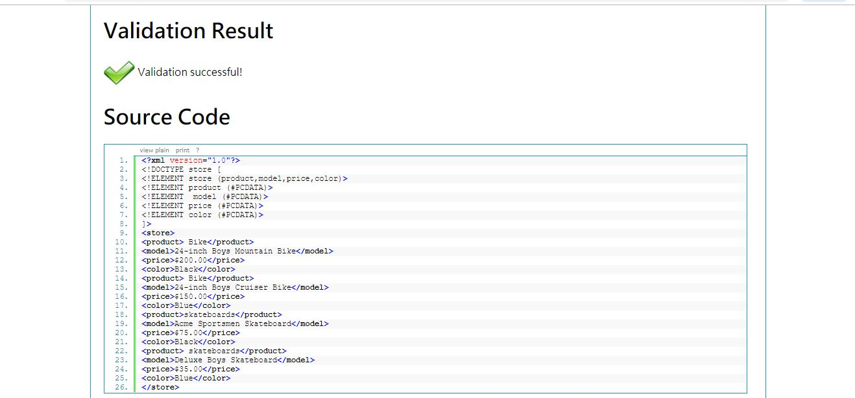

1. Write XML Schema for the following XML document and then validate the XML document along with its schema on the following website:

[http://www.utilities-online.info/xsdvalidation/#.UlFx2tKmhIg](http://www.utilities-online.info/xsdvalidation/)

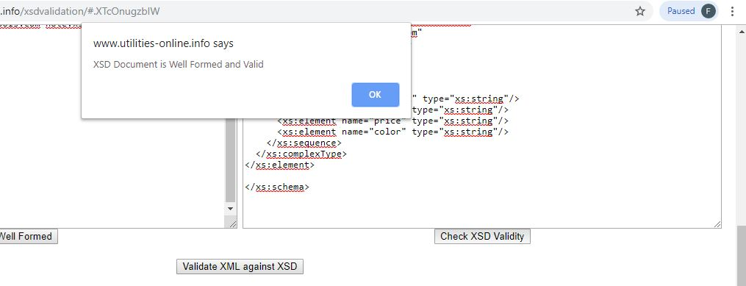

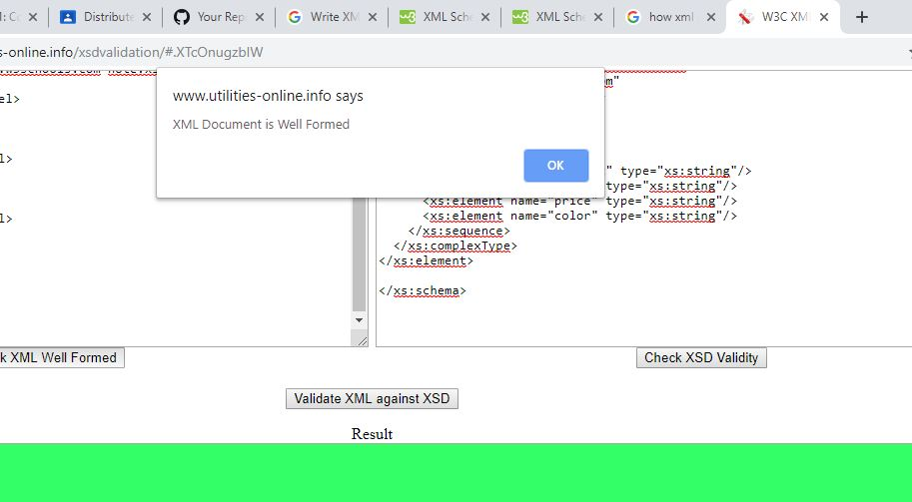

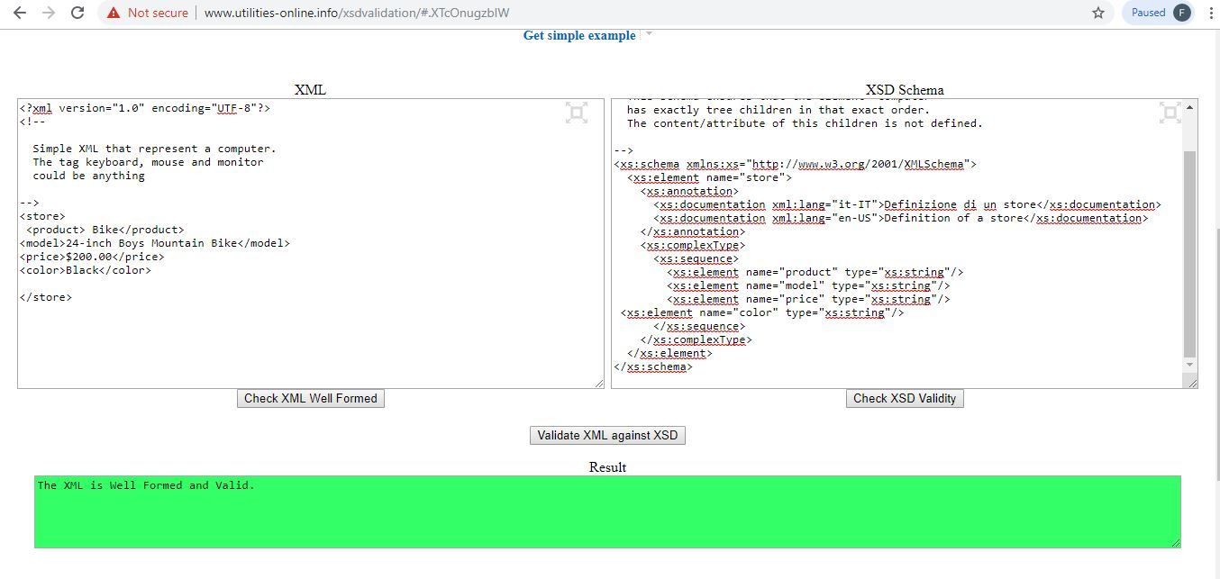

4. Write an XML instance for following schema and then parse that document in Java using either DOM or SAX API.

<?xml version=“1.0” ?>

<xs:schema xmlns:xs=“http://www.w3.org/2001/XMLSchema”>

<xs:element name="person“ type="persontype"/>

<xs:complexType name="persontype">  
<xs:sequence>  
 <xs:element name="firstname“ type="xs:string"/>  
<xs:element name="lastname" type="xs:string"/>  
<xs:element name=“date_of_birth” type=“date”/>

</xs:sequence>  
</xs:complexType>

<xs:complexType name=“date”>

<xs:sequence>

<xs:element name=“day” type=“xs:integer”/>

<xs:element name=“month” type=“xs:integer”/>

<xs:element name=“year” type=“xs:integer”/>

</xs:sequence>

</xs:complexType>

</xs:schema>

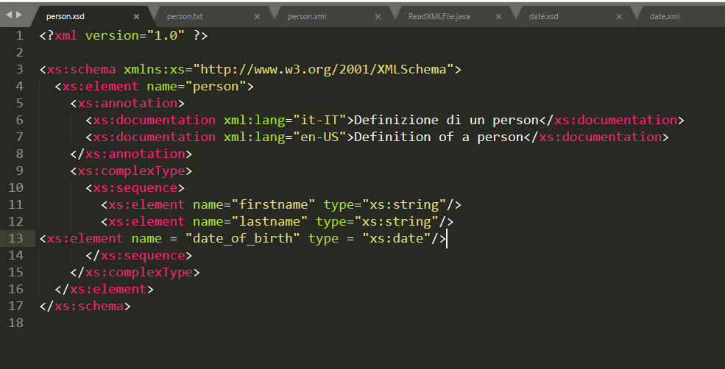

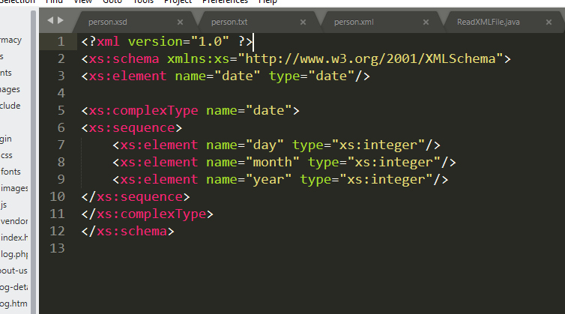

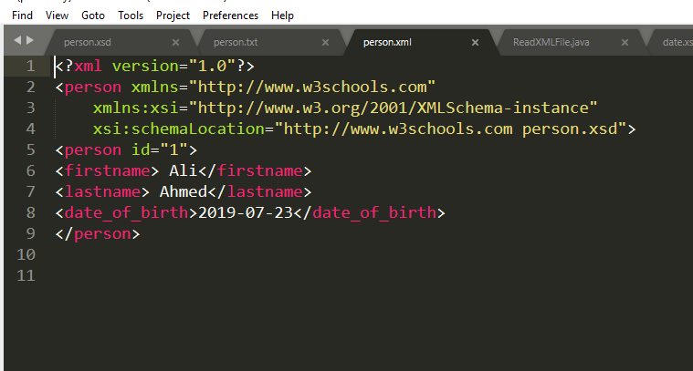

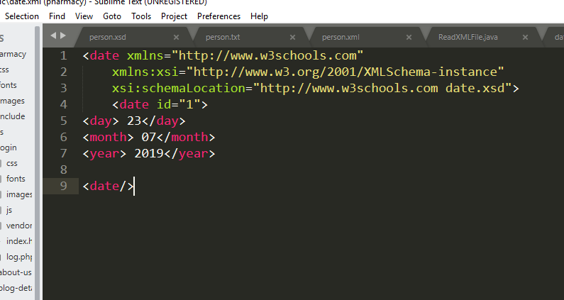

Parse Java Code Using SAX Api:

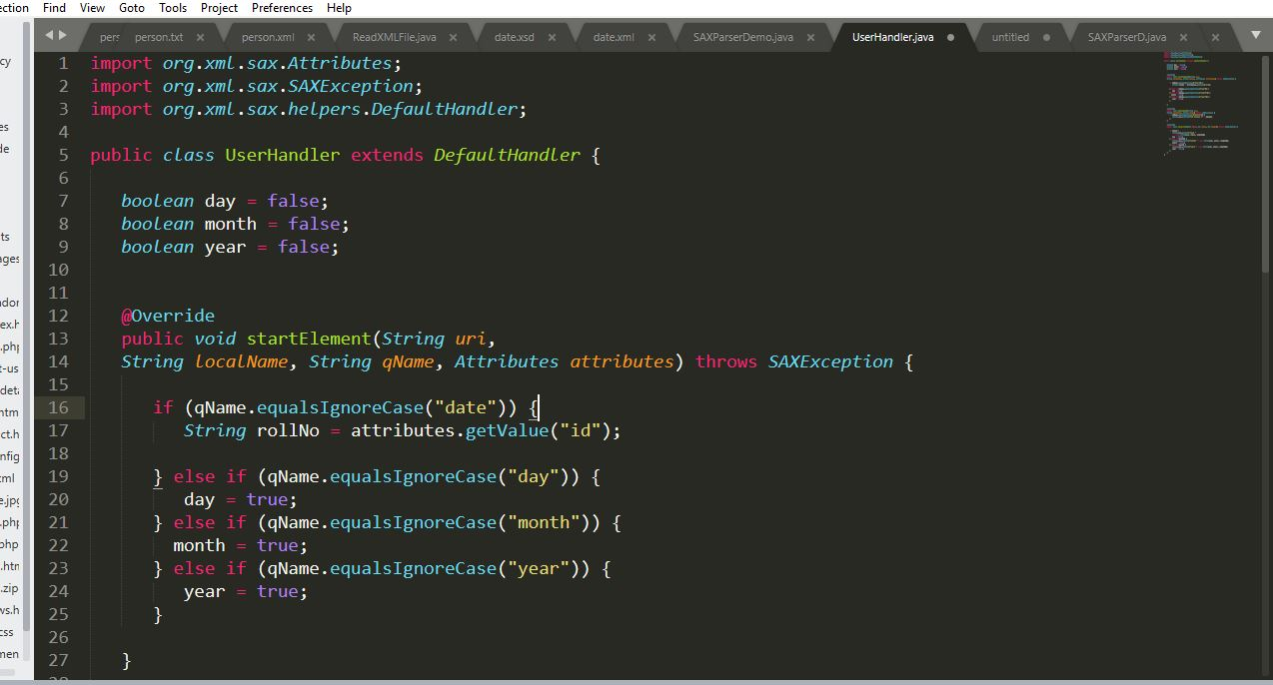

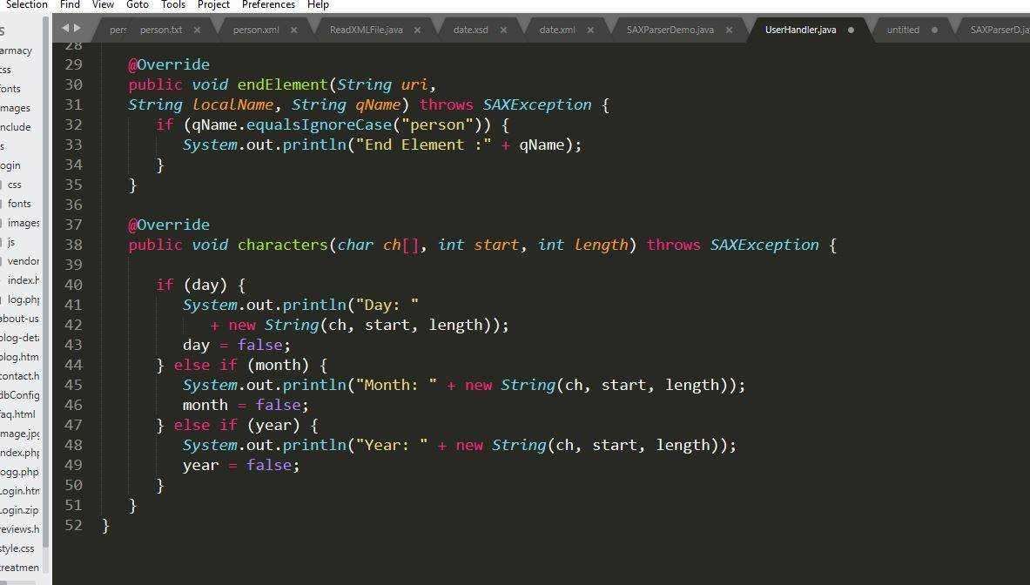

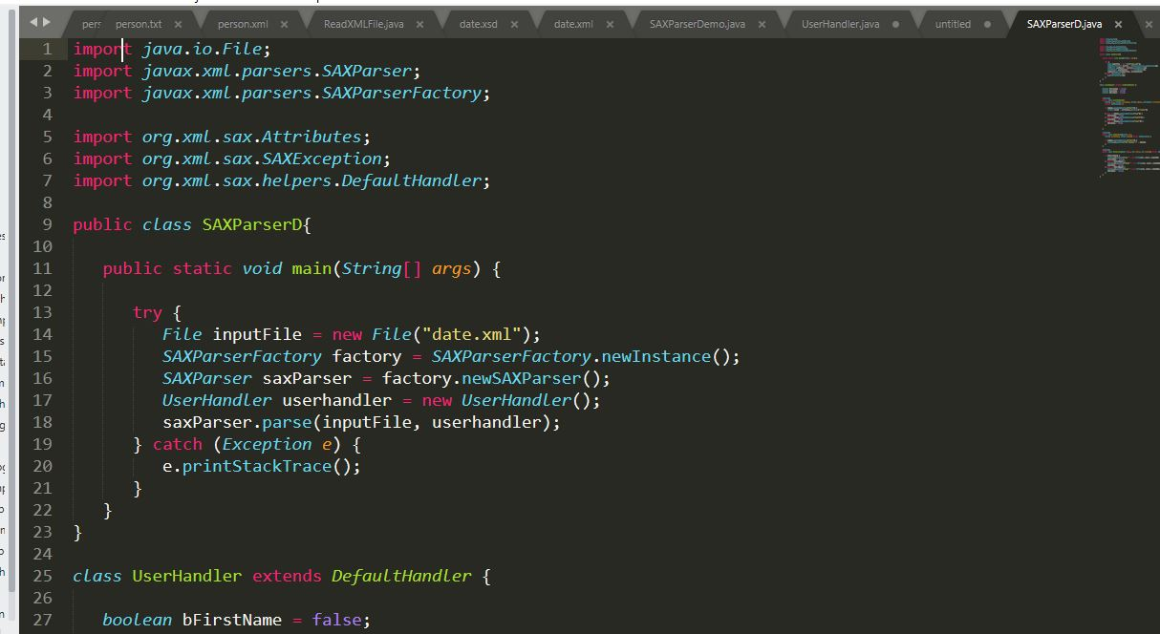

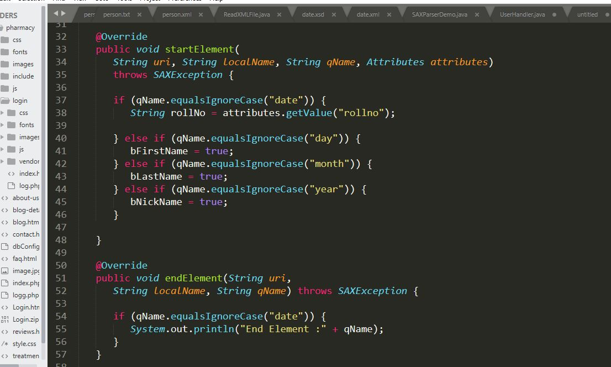

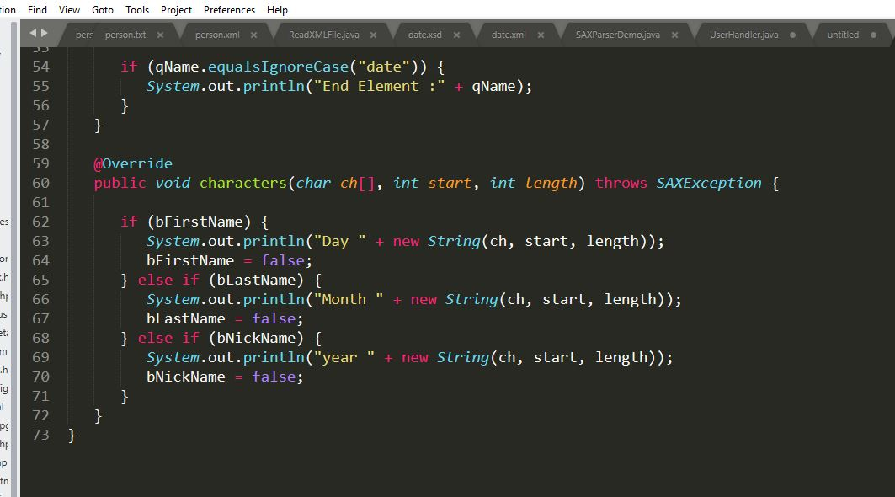

Output:

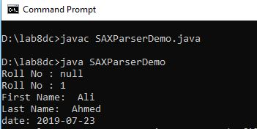 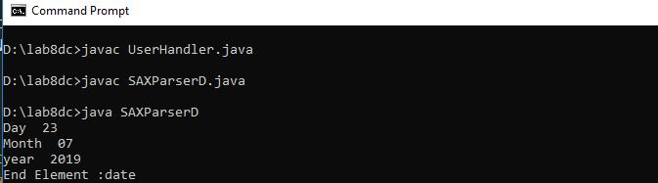

Person:

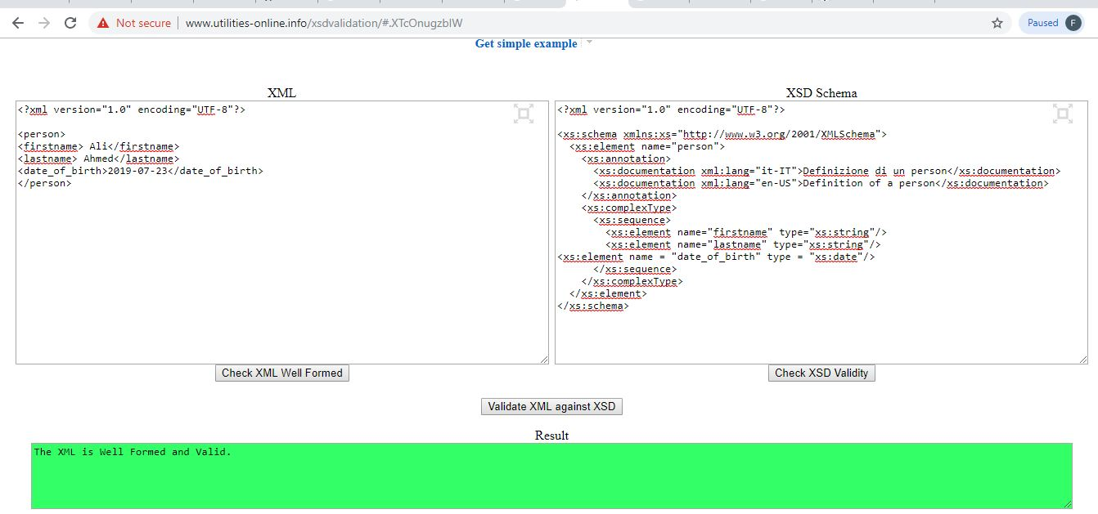

Date:

